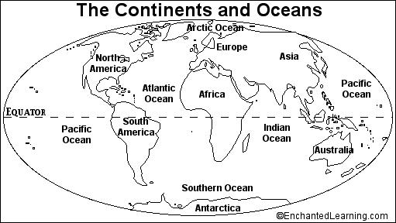
SName___________________________________ Map of World Study Guides

